**ROTATE LEFT OPERATION:**  
**EXP NO: 18**  
**AIM:**To compute rotation of given data in left without carry using 8085 processor.   
**ALGORITHM:**  
1)      Load the base address of the array in the HL register pair.   
2)      Move the data from the memory location into the accumulator.  
3)      Shift left the accumulator content four times.  
4)      Store the result in the specified location.  
**PROGRAM:**  
MVI A,02  
RRC  
RRC  
RRC  
RRC  
STA 2000  
HLT  
**INPUT:**  
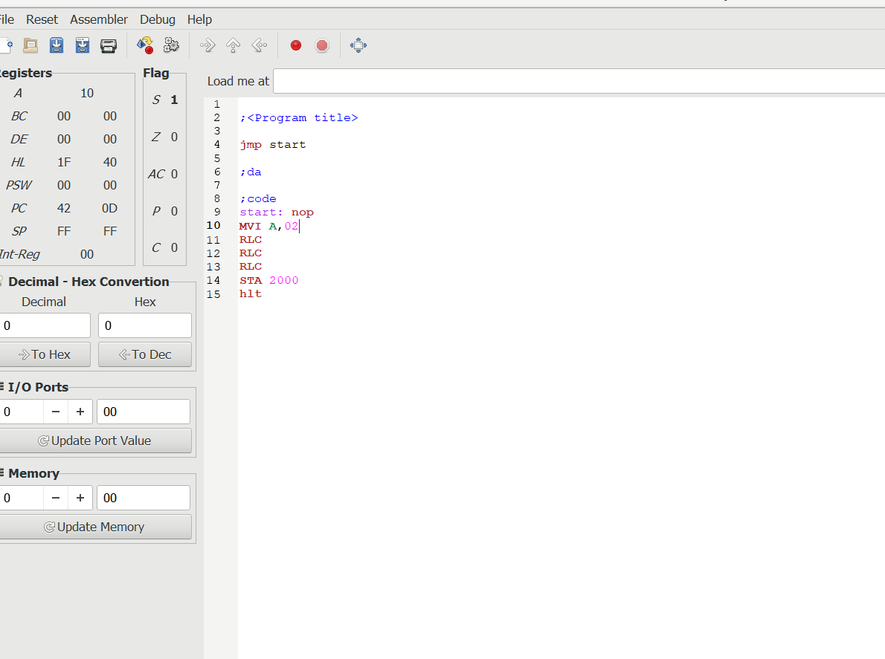  
  
  
  
  
   
  
  
  
  
  
  
  
  
**OUTPUT:**  
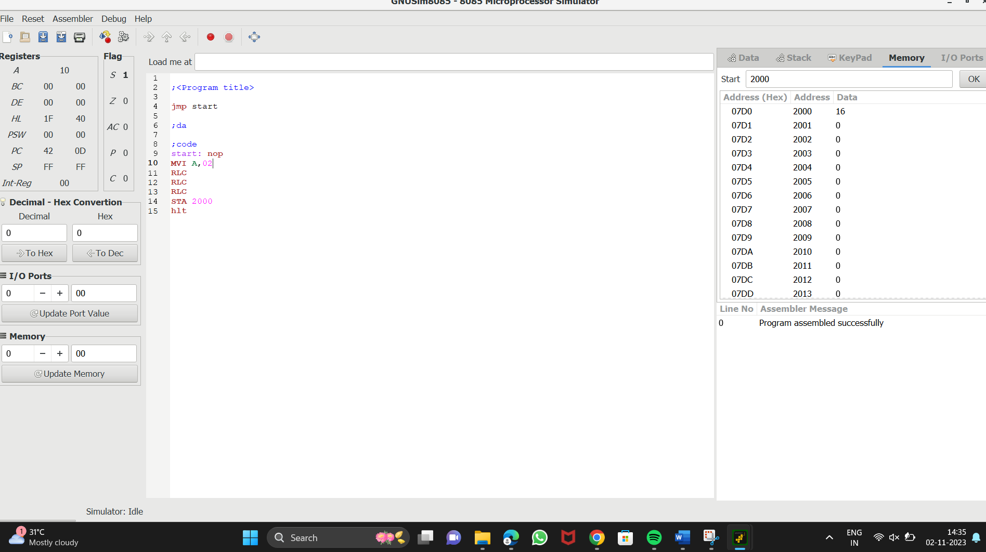  
  
  
  
  
   
  
  
  
  
  
  
  
  
  
  
  
  
  
  
**RESULT:**Thus the program was executed successfully using 8085 processor simulator.